**Corporate Plan**

2023-24

December 2023

Contents

Introduction 3

Acting Inspector-General’s Foreword 3

Purpose 5

Vision 5

Who we are 5

Why we were established 6

Our values 6

Key activities 6

What we do 6

Monitoring 6

Reviews 7

Reports 7

Oversight of complaints management 7

Inform 8

Engage 8

Operating context 8

Environment 8

Capability 9

Workforce 9

Organisational chart 9

Technology 10

Our principles 10

Risk oversight 11

Oversight and assurance 11

Risk management and key risks 11

Cooperation 11

Performance 12

Our objective 12

How will we measure our performance? 12

Interim performance measures for 2023-24 13

# Introduction

## Acting Inspector-General’s Foreword

|  |  |
| --- | --- |
| Photograph of the Acting Inspector-General | As the accountable authority of the Office of the Inspector-General of Aged Care, I am pleased to present our 2023-24 Corporate Plan for the period 2023-24 to 2026-27, as required under paragraph 35(1)(b) of the *Public Governance, Performance and Accountability Act 2013.* The plan sets out how we will deliver on our purpose. |

The commencement of the Office of the Inspector-General of Aged Care (Office) is an historic step. There has never been such a role in aged care or in any other human services policy area in Australia and, as Acting Inspector-General, I am honoured to have the opportunity to lead the Office at this time.

This is the Office’s inaugural Corporate Plan. It marks the start of the new statutory agency and outlines our vision and strategic direction for the next 4 years.

In this early phase of our establishment, our first order of business revolves around completing the set-up of the Office and ensuring we have the staff, policies, procedures, and systems we need to successfully deliver our work. We have already achieved one of our major milestones by delivering the Office’s first Annual Work Plan, which outlines what we are going to focus on in the first half of 2024.

While this is a 4-year plan, it is focussed on the initial tasks that we need to complete in 2023-24 to become fully operational. We will continue to refine our strategic objectives and our performance measures over the next plan and beyond, as we move past our establishment phase.

As a new body we have bold ambitions. We are starting with a robust plan, but it is not set in stone. We will be further engaging with our stakeholders and deepening our understanding of the sector through rigorous monitoring and analysis. This will help us to decide where to focus our efforts, what we can deliver, and what we will prioritise.

**A system with strengths and challenges**

Australia’s aged care system has both strengths and challenges. The sector has many strengths, with a diverse range of providers supporting older people in Australia who need care and support to continue to live in their homes or in residential care facilities.

In recent years we have so often heard about the problems in aged care – and there are certainly many significant issues that are being and still need to be tackled. At the same time there are many success stories in the sector and many aged care providers who do an exemplary job, providing high quality care under the guidance of strong governance and excellent management teams. These organisations should be championed, and their approaches held up as best practice models for broader adoption. This is something the Office will seek to do.

However, there continue to be many deficits in the system. The Royal Commission into Aged Care Quality and Safety (the Royal Commission) found that poor quality aged care is underscored by longstanding systemic issues. These include problems created by or connected to the ways in which government agencies fund, administer and regulate the aged care system.

**The need for greater oversight**

In calling for the establishment of the Inspector-General of Aged Care, the Royal Commission recognised the need for greater oversight of the aged care system as a whole and the actions of government agencies in particular – in addition to the oversight of individual aged care providers, which remains the role of the Aged Care Quality and Safety Commission.

We will use our role to improve the transparency and accountability of the system and the sector, and we will address the areas that need critical improvement to deliver better administration and regulation of aged care.

We will do this by examining areas of weakness in depth, identifying the root causes of problems, and making recommendations for change. We will report publicly and to the parliament and we will make recommendations for meaningful change. We will monitor developments in, and look to improve, the existing complaints management framework.

I look forward to working closely with our stakeholders and my outstanding team to further improve the delivery of aged care in Australia to achieve better outcomes for older people who need support and care.

**Ian Yates AM**

Acting Inspector-General of Aged Care

15 December 2023

# Purpose

Our purpose is to provide independent oversight of the aged care system and to drive accountability and positive change through reviews, recommendations, and reporting to parliament.

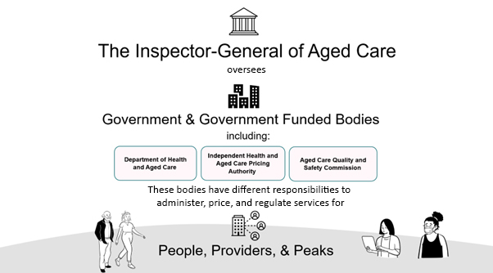To do this, we monitor, review, and report on the aged care system, call out significant and systemic issues, and make recommendations.

## Vision

Our vision is to be a trusted authority that ensures integrity and accountability in the aged care system by providing informed and independent oversight. We will be a catalyst for change by calling out problems and identifying areas for improvement to help ensure that older people can access the care they need.

## Who we are

The Government established the Inspector-General of Aged Care (Inspector-General) and the supporting Office of the Inspector-General of Aged Care on 16 October 2023 through the *Inspector-General of Aged Care Act 2023* (IGAC Act). The IGAC Act sets out the functions and powers of the Inspector-General and supporting Office.

The Minister for Aged Care appointed an Acting Inspector-General on 16 October 2023, to perform the role while a formal recruitment process to appoint an Inspector-General is conducted in line with the Cabinet Handbook. The appointment of an Inspector-General will be a decision of government.

Before our establishment as a statutory agency, we operated as an interim office within the Department of Health an Aged Care. Mr Ian Yates AM was Interim Inspector-General of Aged Care from 31 January 2023 until commencement of the statutory agency.

## Why we were established

The Royal Commission recommended that the Australian Government establish an Inspector-General and supporting Office to ensure the aged care system is operating effectively, to call out issues and recommend solutions, and to report to parliament and publicly. Establishment of an Inspector-General was one of the 148 recommendations for reform contained in the Royal Commission’s Final Report [1].

The Inspector-General in particular has a role in reporting regularly to parliament on the Commonwealth’s implementation of Royal Commission recommendations, with timing set out in the IGAC Act.

## Our values

The Office upholds the Australian Public Service (APS) Values and Code of Conduct, as outlined in the *Public Service Act 1999*.

We have been entrusted by the government and community to provide independent oversight of the aged care system and with this comes a high level of responsibility. We are committed to embedding accountability and integrity into our own activities, ensuring our processes are transparent and free from bias, and always behaving ethically and professionally.

# Key activities

## What we do

We help to improve the aged care system through in-depth investigations and independent recommendations to the Australian Government and parliament. We also monitor the way that complaints are managed by the various government bodies responsible for them.

### Monitoring

Monitoring is the foundation of everything we do. Effective monitoring tells us how the aged care system is operating and helps us decide where to focus our efforts.

Our monitoring program will regularly gather data from the government bodies that administer, fund, regulate and deliver the aged care system. But this is just one component of our overall monitoring strategy. To maintain a comprehensive understanding of the broader issues affecting aged care, we collect intelligence from a range of sources including:

* consumers of aged care, including older people, their carers, and families
* providers, aged care workers and peak representative bodies
* national and international journals and reports
* academics and researchers
* media and commentators.

Our analysis of the intelligence that we collect through our monitoring activities will inform all the activities in our Annual Work Plan, including our reviews, reports, and engagement.

### Reviews

We help to improve the aged care system by doing in-depth investigations and providing independent advice to the Australian Government and parliament through:

* examining a systemic issue or topic that affects the government's regulation, administration, or funding of aged care services or the delivery of those services
* writing a review report
* publishing the review report on our website, which the Minister for Aged Care tables in parliament
* making recommendations for change to the government and parliament.

### Reports

We produce a range of reports that fit broadly into three categories:

* **progress reports** that provide updates on the implementation of Royal Commission recommendations
* **standalone reports** on specific topics or matters relating to the aged care system – for example, reports on performance of other government bodies, issues-based reports, aged care data reports, and review update reports
* **corporate reports** including our corporate plan and annual reports.

We publish our reports on our website and the Minister for Aged Care tables them in parliament.

### Oversight of complaints management

We monitor the way that complaints processes in the aged care system are managed by:

* government agencies
* approved providers
* other aged care bodies funded or regulated by the Australian Government.

We look at how they manage their complaints and recommend ways to improve their complaints processes. This is to ensure complaints management processes in aged care are:

* fit for purpose, effective, efficient, and accessible
* delivering appropriate outcomes.

The Inspector-General does not have the power to investigate individual complaints about aged care. This remains the responsibility of the agency or body that the complaint is about, or of the Aged Care Quality and Safety Commission when complaints about providers are referred to it.

### Inform

We see ourselves as having a significant role in informing government and community about the weaknesses and successes in the sector and driving positive change for older people who need aged care. We will share the insights we obtain through our analyses, reviews, and reports – and highlight best practice approaches – with the aim of encouraging greater innovation and compliance in the aged care system.

### Engage

Engagement is an ongoing and integral part of our work. We will continue to look for ways to expand our engagement activities to ensure we can talk to and hear from older people, their families, carers, providers, the aged care workforce, researchers, and their representative peak bodies.

We will build and maintain our capability to engage effectively and openly with our target audiences to inform our analyses, reviews and reports. We are committed to engaging with people from all backgrounds and needs, including First Nations people and providers, people with disabilities, people with caring responsibilities, people who identify as LGBTQIA+, people from cultural and linguistically diverse backgrounds, and people who identify as neurodivergent.

# Operating context

## Environment

As a new statutory agency our focus in 2023-24 and over the next 4 years will be on establishing the Office as a trusted authority that ensures integrity and accountability in the aged care system.

Our immediate priority is to continue to build the strong foundations needed to position us well for the future. This includes embedding our accountability, risk management and governance frameworks and practices, building our staffing levels and capability, building our systems and technology, and establishing our processes and policies.

On 15 December 2023, we published our first Annual Work Plan, which outlines the activities that we will complete in the remainder of the 2023-24 Financial Year. Publication of an Annual Work Plan is required under our legislation. It includes details of our first review and our second progress report[2] on the Commonwealth’s implementation of the Royal Commission recommendations, which will examine reform implementation up to 31 December 2023.

The IGAC Act gives us independence and the legislative powers to fully investigate systemic issues across the aged care system, to help make services better meet the diverse needs of older people in Australia. But we are acutely aware that we are operating in a sector that is undergoing significant reform and we are committed to understanding and responding to changes in our operating environment.

Key reforms resulting from the Royal Commission that will affect and influence our work over the 4-year period of this plan include the government’s delivery of a new Aged Care Act, a new Support at Home program, and responses to the recommendations of the Aged Care Taskforce. With those factors in mind, we will continue to monitor developments and remain engaged, adaptive, and dynamic to bring about positive change to the aged care system.

## Capability

We seek to drive meaningful change across the aged care system. As a small agency with a broad remit, we will use our available resources strategically and focus on key priorities to have maximum impact and meet the high expectations set for us as an independent oversight body. We will focus on building and enhancing our workforce capability and developing our technology to successfully deliver on our purpose and outcome.

### Workforce

Our funding from the Australian Government for operating and capital expenses is $38.7 million over four years from 2022-23. Our staffing levels are currently 21 full-time equivalent positions over the four-year period of this plan, in addition to the Inspector-General. Our staff are employed under the *Public Service Act 1999,* with terms and conditions set out in a section 24(1) Determination under this Act. During 2023-24 we are endeavouring to negotiate an enterprise agreement which will provide terms and conditions of employment moving forward.

### Organisational chart

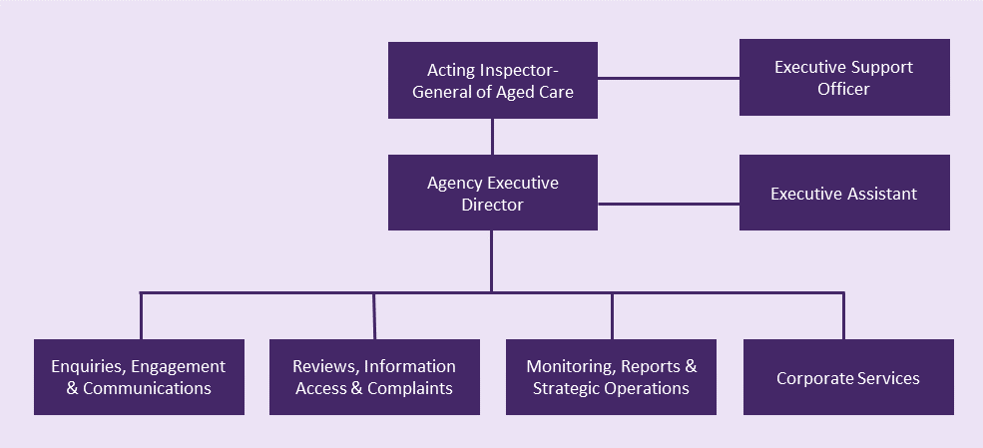

Our staffing profile comprises a mix of ongoing and non-ongoing employees, deployed flexibly to respond to business needs and priorities, with experience and expertise in areas including management, law, data and analytics, finance, systems management, communications, and human resources. While they each have specific roles and responsibilities, our staff remain agile to meet the challenges of a dynamic work environment with simultaneous demands and variable priorities. By having our people work across teams, we can maximise our expertise, build capability and produce results that benefit the agency and the public. We will continue to direct efforts toward attracting and retaining capable and high calibre staff, and to invest in the professional development of our staff.

We will continue to refine our organisational structure as we establish our agency. We strive to create a diverse and inclusive workplace with a workforce that represents and understands the needs of all Australians.

In-line with the broader government approach towards Reconciliation, the Office will commence the development of its first Reconciliation Action Plan in 2024-25. The Reconciliation Action Plan will form part of our overarching Diversity and Inclusion Strategy also under development.

### Technology

We are building the Office’s technological capacity to ensure we have robust, reliable, and effective ICT services that suit our requirements. This includes:

* Customer Relationship Management (CRM) technology to manage our relationships and interactions with our stakeholders
* a data warehouse to store our data so that it remains safe and protected
* developing data analytics capabilities with business intelligence tools to analyse and gain insights from the data we collect
* ensuring our cyber-security arrangements are strong to protect our information.

In designing our business systems, we are considering the needs of our staff and of our audience. We will continue to balance our intelligence approach with available resources.

## Our principles

Our 6 guiding principles underpin our work. They influence how we conduct ourselves, how we operate, and how we achieve results.

|  |  |  |  |  |
| --- | --- | --- | --- | --- |
| Users outline | **People Centred**  We put the interests of older people in Australia first. This helps to ensure the aged care system supports living well and healthy ageing. |  | Cheers outline | **Inclusive**  We support equal access for all older people in Australia. We embrace their diverse backgrounds and life experiences. |
| Checklist outline | **Accountable**  We hold government and regulatory bodies to account. We provide greater checks and balances on their performance, effectiveness, and outcomes |  | Target Audience outline | **Evidence Based**  We use robust data and evidence to oversee the system, and call out areas where data is inadequate. |
| Weights Uneven outline | **Objective**  Our findings and recommendations are fair and impartial. We are not compromised by prejudice, bias, conflict of interest, or undue influence of others. |  | Clipboard Badge outline | **Excellence**  We recognise and promote excellence in regulation and innovation. We aim to build public confidence in Australia’s aged care system. |

## Risk oversight

### Oversight and assurance

Our corporate governance framework will be critical to managing our strategic and operational activities to ensure we achieve our purpose and deliver on our objectives.

Our independent Audit and Risk Committee is established and held its first meeting in November 2023. Over the remainder of 2023-24, we will continue to finalise and embed our formal governance arrangements to provide a clear structure and processes.

### Risk management and key risks

Risk management will play a crucial role in shaping the strategic direction of the Office. We are working to establish a risk management framework which will encompass our risk management policies and a risk register, to help us to identify, respond to, and actively manage our key risks.

As a new entity, our key corporate focus is on ensuring we develop and embed an effective and fit-for-purpose governance framework which will enable consistent processes, appropriate oversight, and suitable documentation across the organisation.

Risk management is everybody’s responsibility, and we will continue to encourage early engagement and open conversations about risk. We see this as an essential factor in identifying and assessing emerging or new risks that may impact our business, and deciding how we mitigate and manage them.

### Cooperation

We operate with independence and impartiality, but we do not work alone. We have built and will continue to build cooperative working relationships with the agencies we oversee, particularly:

* Department of Health and Aged Care
* Aged Care Quality and Safety Commission
* Independent Health and Aged Care Pricing Authority

As a priority, we will establish Memoranda of Understanding with each of these entities to ensure we can access the information that we need to monitor and analyse performance of the aged care system.

Our Office will also continue to work with older people, their carers, families, providers, the aged care workforce, researchers, and peak representative bodies, to identify issues in the aged care system and to improve awareness of our Office. We have established a Consultative Committee comprised of consumer, provider and workforce representatives that provides a regular forum for the exchange of ideas. We will seek opportunities to engage more broadly and focus our resources to ensure we reach our target audiences effectively.

# 

# Performance

## Our objective

The **outcome objective** that our overall performance will be assessed against is:

Provide independent oversight of the aged care system to drive accountability and positive change through reviews, recommendations, and reporting to Parliament.

### How will we measure our performance?

As noted throughout this plan, we are in the early stages of establishment and as such, our agency objectives are unique for 2023-24. We have developed a set of interim performance measures that centre around establishing our accountability and governance frameworks and commencing our oversight role.

We will continue to refine and build on these performance measures in our 2024-25 plan and beyond, which is when we expect to include more focus on measuring our effectiveness in delivering on our purpose to provide independent oversight of the aged care system to drive accountability and positive change.

To deliver on our outcome we have **two strategic objectives**:

1. **Establish the Office’s accountability and governance frameworks as soon as possible and no later than 30 June 2024.**
2. **Commence independent oversight of the Commonwealth’s administration of the aged care system.**

The table below outlines how the Office will measure its performance in 2023-24 against its strategic objectives.

## Interim performance measures for 2023-24

|  |  |  |
| --- | --- | --- |
| **Key performance measure** | | **Target** |
|  | **Establish accountability and governance frameworks by 30 June 2024** | |
| **1** | Audit and Risk Committee established | 15 December 2023 |
| **2** | Consultative Committee and other committees established[3] | 30 June 2024 |
| **3** | Systems of risk management and control designed and implemented | 30 June 2024 |
| **4** | Memoranda of Understanding (MoUs) to cover the routine collection of data are established | 30 June 2024 |
| **5** | Office functions established | 30 June 2024 |
| **6** | Governance policies developed and published | 30 June 2024 |
|  | **Commence monitoring, investigating, reviewing, and reporting on the aged care system** | |
| **7** | Annual Work Plan (AWP) published | 1st AWP published by 15 December 2023 |
| **8** | Effective stakeholder engagement through meetings with consultative committee, other advisory bodies, agencies, organisations, and the public | 16 meetings held |
| **9** | Reports and reviews are delivered and published within agreed timeframes | 1 review report published |
| **10** | Percentage of recommendations in public reports accepted by the agency or organisation or government | 70% accepted[4] |
| **11** | Reports on implementation of Royal Commission recommendations delivered within statutory timeframes | 1 report published |

****www.igac.gov.au

1. The Royal Commission into Aged Care Quality and Safety Final Report: Care, Dignity and Respect was tabled in parliament on 1 March 2021 – <https://www.royalcommission.gov.au/aged-care/final-report>
2. The Interim Inspector-General of Aged Care prepared the first progress report on the implementation of recommendations from the Aged Care Royal Commission in July 2023. It was published in October 2023.
3. An interim Consultative Committee was established in March 2023 to advise the Office of the Interim Inspector-General. The committee was retained following establishment of the statutory Office and will continue until 30 June 2024 or until a decision is made on the future consultative structure for the Office.
4. The Office has set an initial target of 70%. This will be reviewed and adjusted in future corporate plans when we will have a more accurate measure of how our findings are accepted.